Federated Learning and Privacy-Preserving Agentic AI in Healthcare
Abstract
The convergence of Federated Learning (FL) and Agentic Artificial Intelligence (AAI) represents a pivotal advancement in healthcare innovation. This chapter explores how FL facilitates decentralized AI model training across hospitals, medical devices, and research centers, safeguarding sensitive patient data to meet stringent privacy and regulatory requirements. Integrating AAI into FL frameworks empowers autonomous systems to reason, adapt, and make informed medical decisions without centralizing data aggregation. Beginning with foundational insights into FL and its pivotal role in modern healthcare, this chapter demonstrates how distributing model training across devices and institutions minimizes data breaches, ensures compliance with healthcare regulations such as (Health Insurance Portability and Accountability Act) HIPAA and (General Data Protection Regulation) GDPR, and fosters collaborative research. Agentic AI systems, characterized by autonomy, goal-driven behaviour, and contextual adaptability, are essential for future intelligent medical assistants, diagnostic tools, and decision-support systems. The chapter introduces architectures that merge FL with AAI, leveraging privacy-preserving technologies like differential privacy, homomorphic encryption, and secure multi-party computation. These methods ensure individual data points remain inaccessible during collaborative model training. Case studies, including collaborative oncology diagnostics and pandemic outbreak tracking, illustrate practical applications and tangible impacts on patient outcomes. Critical challenges such as communication overhead, model bias from non-IID(NonIndependent and Identically Distributed) data, adversarial attacks, and trust issues are examined in depth. Ethical considerations regarding AI explainability, fairness, and accountability are also discussed, offering a comprehensive perspective. Looking forward, the chapter explores future directions such as personalized healthcare, adaptive clinical trial optimization, real-time multi-agent health monitoring networks, and the development of interoperable, cross-border healthcare systems enabled by federated agentic AI. This synthesis aims to provide researchers, developers, and healthcare practitioners with a roadmap to build secure, privacy-conscious intelligent healthcare ecosystems[1][4][6].
1.Introduction
As we know Artificial Intelligence (AI) is a powerful field of computer science, which has the potential to transform the practice of medicine and the delivery of healthcare[1]. As we know data privacy is the most important thing a authority could hold.
Why is Data Privacy Important in healthcare?
Data privacy in healthcare refers to protecting sensitive patient data like medical history, treatments, insurance data etc. In healthcare protects the sensitive information of the patients from the unauthorized access. The major challenge of healthcare data privacy is the safety of Electronics Health Records (EHRs) data. The wide use of EHRs caused the collection and transfer of large amount of patients[5].

Federated Learning (FL) is a machine learning approach that enables the shared AI models to be trained from many decentralized devices without the exchanging of local data samples. It is particularly significant as health data is highly important and sensitive which is governed by strict regulations like HIPAA[4]. Agentic AI is an advanced form of AI that focuses on autonomous decision-making and action. It requires the constant human prompting or the predefined rules, sets its own goals, plan and execute tasks with the minimal human interactions.

This chapter explores the FL and Agentic AI in healthcare , the two advanced AI technologies could be combined to create the secure & efficient healthcare. It addresses the critical issue of the data privacy in healthcare, highlights the risks like data leakage and re-identification.

2. Foundations of Federated Learning (FL)
2.1 Concept of Federated Learning
Federated Learning (FL) which is also known as collaborative learning is a machine learning technique where various entities collaboratively trains the model by keeping their data decentralized. It is generally concerned & motivated by issues like data privacy, data rights etc. The principle consists of the training of local models on the local data samples and exchanging parameters between the local nodes at some frequency to generate the global model shared by all the nodes[4].
2.2 Relevance of Federated Learning in Healthcare
Federated Learning (FL) is highly demanded in healthcare due to its sensitive nature of health data and data privacy. The traditional ML approach requires the centralized data which poses the significant risks like data leakage and sometimes re-identification[4][6]. Federated Learning addresses these by allowing a shared model to be trained using data from various decentralized devices (like hospitals devices) without moving the data from its original location.
Many real world applications of FL which have emerged in healthcare :
- Remote Patient Monitoring and personalized care : It can be used to analyze the data from health devices and other sensors to provide the personalized care without the centralized data. The data remains on the local devices while contributing to the overall model improvement.
- Chronical disease prediction and management : FL is applied to manage and predict the chronic diseases with the use of data from various sources like hospital networks and electronic health records (EHRs), without the need of data collection.
- Telemedicine : In telemedicine FL ensures that the data used for making the predictions remains confidential .
The decentralized learning keeps the data from where it originates. Instead of moving the data to the model, the model is sent to the data’s location on the local device or server. FL encourages the formation of global healthcare that can collaborate without compromising the individual’s privacy[4].

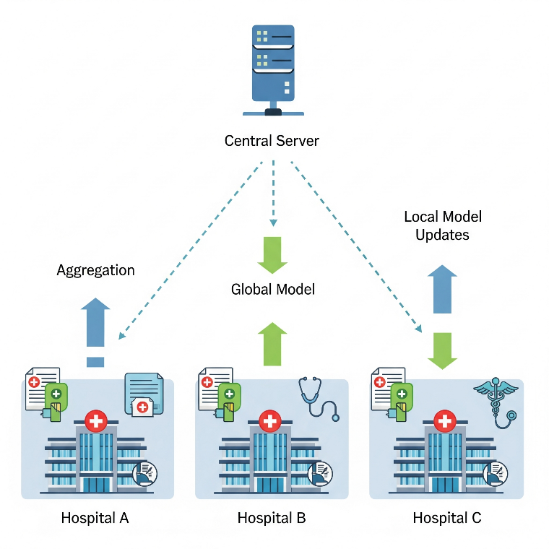
Figure1. Federated Learning workflow in healthcare
The image illustrates a typical FL workflow in a healthcare context, using a client-server architecture where the global model is sent back to hospitals for the another round of local training refining the model’s accuracy and generalization across diverse datasets, maintaining the data privacy of all patient information at the local site.
3. Agentic Artificial Intelligence in Healthcare
3.1 Concept and Characteristics: Agentic AI
Agentic AI refers to the advanced form of artificial intelligence which can perform autonomous actions & decision-making. It operates with the minimal human interventions, pursue predefined goals and adapt to the learning through learning & reasoning. It is a technology which functions like a “teammate” with the potential to transform the diagnostics, patient management an treatment planning[2].
Core features of the Agentic Artificial Intelligence includes:
- Proactivity : Consists of the actions that has the ability to solve its own problem and achieve its goals.
- Reasoning : It can analyze the large amount of data which includes the patient history , medical history etc to make action plan and logical decisions .
AAI in healthcare means the AI systems that are made to be autonomous , capable of reasoning and allowing them to perform various tasks and even make decisions with the minimal human interventions .
It can be applied in many healthcare scenarios to improve their decision making and efficiency.
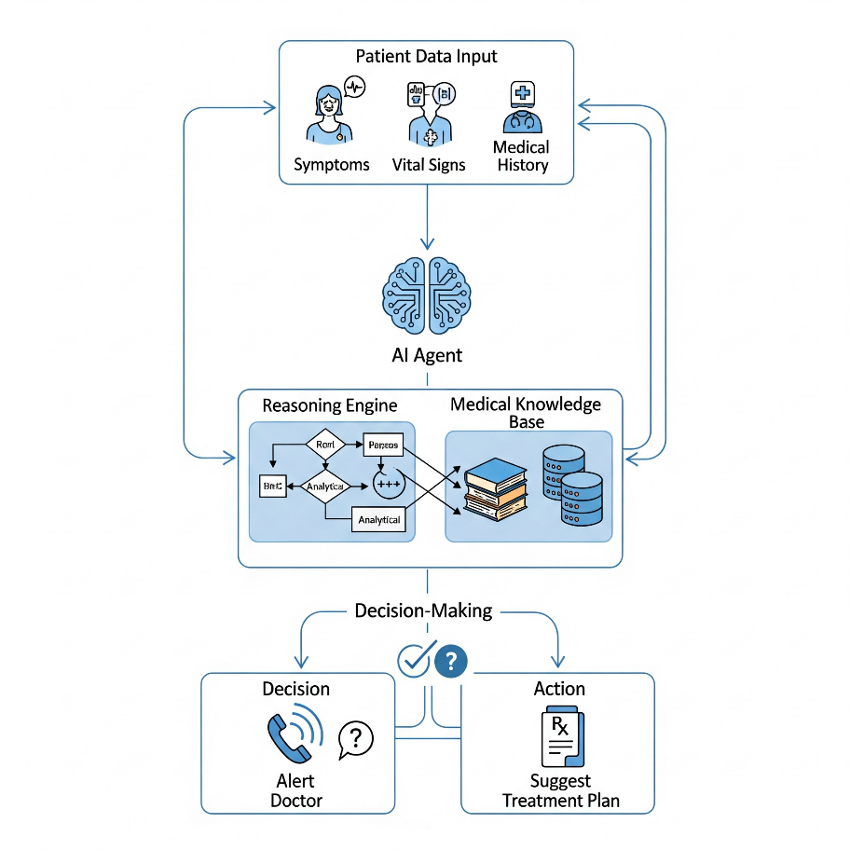
Figure 2.: Agentic AI decision- making process in healthcare
The image above illustrates that how an AI agent takes the Patient Data as input, and uses its IRE (Internal Reasoning Engine) and Medical Knowledge Base to process which then outputs the decision. Now, the decision leads to an action.
3.2 Examples of Agentic AI In Healthcare
Some of the examples of agentic AI in healthcare for decision-making and diagnostic support [1] are as follows:
- Medical Image Analysis: Tools like CT scans, MRIs could easily be detected by the AAI with an accuracy and speed that can even surpass human capabilities.
- Clinical Decision Support Systems : The intelligent & proactive agents independently analyze the vast datasets which includes medical images , electronic health records so that they could provide the treatment plans for the same.

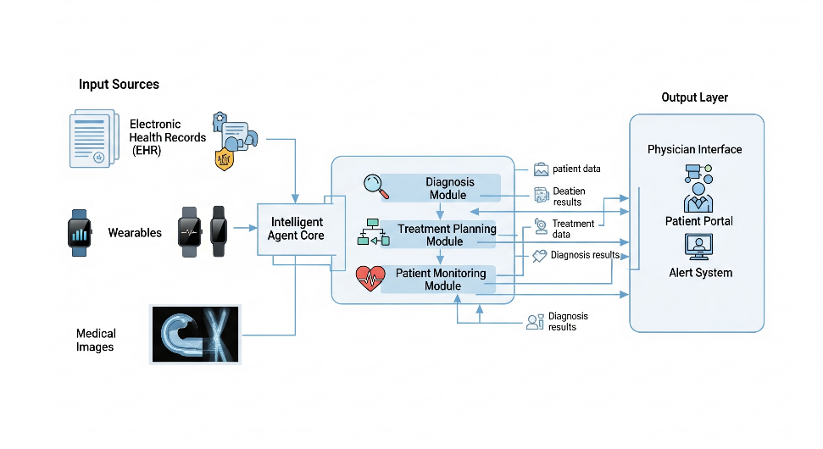
Figure 3.: Architecture of Healthcare Intelligent Agent
The above image illustrates how the architecture of healthcare Intelligent Agent is designed which enables the agent to act proactively , anonymously & even with reasoning capabilities.
4. Privacy Concerns in Healthcare AI
4.1 Sensitive nature of health data
In the era of large public digital repositories of data , the data privacy has increased and become a matter of concern . And mostly true in healthcare because here the data of each patient could be misused . Several factors through which sensitivity of the data could be rooted :
- Ethical Implications: Without the proper consent, the use of health data for the training of AI models could lead to ethical dilemmas & sometimes even legal disputes over their data ownership which often is unclear because who owns the data once is accessed by the third – party AI developers .
- Higher Value to Cybercriminals: The health data of particular patients which includes a patient’s name, home address, medical history makes it even more valuable to the black market , which makes the healthcare organizations major targets for cybercrimes/attacks[5].

4.2 Regulatory Framework
Various use of health data is governed by the regulatory frameworks which are made to protect the patient privacy and ensure the data security .
Health Insurance Portability and Accountability Act (HIPAA), it is a regulation in U.S that establishes that the protection of patient health information which includes privacy and security rules for electronic protected health information[4].
National Digital Health Mission (NDHM) in India which aims to digitize the healthcare ecosystem & even establish the health data management policy for privacy and security of each individual’s health data. It is based on the federated architecture to enhance the security[5].
5.Privacy-Preserving Techniques in Federated Learning:
5.1 Differential privacy
Differential Privacy is a privacy preserving technique which is used in federated learning to protect the individuals data by adding the controlled amount of “noise” to the model or data updates. Main goal is to make it statistically impossible to check whether each individual’s data was included in the training dataset or not.
Even if one person’s data is added or removed the outcome of the data analysis / model should stay the same. It is generally achieved by adding random noise which ensures that even if a small change is there in any individual’s data , it will not change the outcome of the analysis[6].
5.2 Homomorphic Encryption
It is a privacy-preserving method which lets the computation to be done directly on encryption data without needing to decrypt it which means any third-party like cloud server could analyze the data without getting the access to the unencrypted data information . Model updates which are sent from clients to central server are protected by the homomorphic encryption(HE). Clients directly encrypts the data with the use of HE before transmitting them. The central server collects the encrypted updates without breaking them down. After collecting the final results could be sent back to a trusted entity for decryption which reveals the updated global model without any third-party having seen the sensitive individual updates.
Therefore, it makes the strong protection against data leakage[7].
5.3 Secure multiparty computation (SMPC)
It is a cryptographic protocol which allows many parties to come together and compute a function on their private data but without revealing each individual’s inputs to each other. SMPC could be used securely to combine the model updates from multiple clients.
Principles of SMPC in federated learning are as follows:
- Privacy-preserving Aggregation: Every client encrypts its model updates before sending them. Aggregation function is computed on the encrypted data which results in the encrypted sum of the updates & then the sum is sent to the central server.
- Applications in Healthcare: It can be used for enabling multiple hospitals to securely train model together on the basis of their patient data without revealing each individual’s records[10].
5.4 Example Frameworks and Platforms
Various number of open source frameworks & platforms developed for the support of federated learning (FL) :
- PySyft : It is an open source python library which is used for privacy- preserving machine learning. It supports differential privacy, federated learning and encrypted computation[10]. Without ever seeing or obtaining a copy of the data itself, it enables data scientists to conduct machine learning on data that is stored on another person's server.
- NVIDIA FLARE (Federated Learning Application Runtime Environment): open-source, domain-neutral SDK facilitates multi-party cooperation in the development and validation of AI models while safeguarding user privacy.
In order to support cross-border federated agentic AI networks the future architectures are most likely to include interoperable data exchange standards, self-governing entity systems and block chain based trust mechanisms.
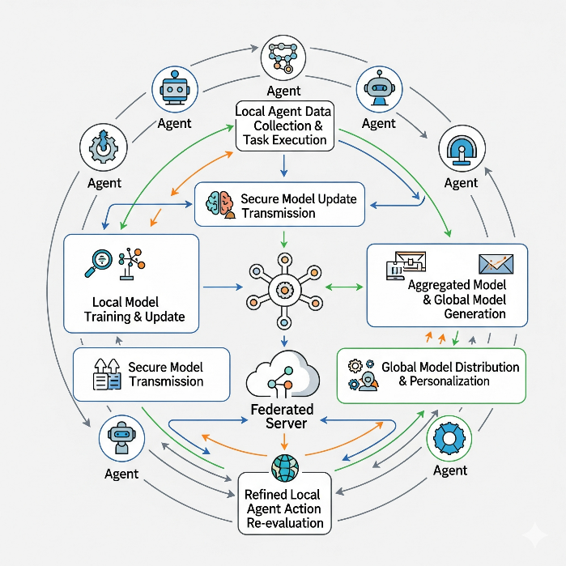
Figure 4.: End to end federated agentic ai workflow
The above fig explains that multiple decentralized agents can work together to learn while protecting data privacy because of end-to-end federated agentic AI workflow.

6.Case Studies and Applications:
The below section provides the practical case studies which could demonstrate how federated agentic AI could contribute to improve the data privacy , medical outcomes & various research.
6.1 COVID-19 Diagnosis
The COVID-19 started spreading since 2019 which resulted in high transmission , morbidity and mortality rate. FL in COVID-19 diagnosis helped partially to break the low model performance due to insufficient medical data. For example, by letting various hospitals train the model using their patient data, a global model for COVID-19 detection from chest X-rays was created. The central server could only get the updates from the hospitals & then it would combine to create more reliable and accurate model which could diagnose COVID-19 .

Metric | Centralized Learning | Decentralized Learning
Accuracy | 97.6% | 96.7%
Precision | 96.2% | 95.5%
Recall | 97.9% | 96.4%
Table : COVID-19 CT/X-ray Diagnosis – Centralized vs. Decentralized Model Performance
From Table 1 the centralized training performs better across all metrics , but on the other hand FL ensures that patient’s sensitive data never leaves the local hospital servers[9].
6.2 Predictive Analytics in Telemedicine
It focuses on patient data to health risks which ensures that the data remains confidential. Smart healthcare systems predicts cardiovascular disease by utilizing block chain technology , ML and homomorphic is one of the example. Using the homomorphic encryption scheme before it could sent or stored in the cloud , first the patient’s sensitive data is encrypted , and this makes it possible to use predictive models with encrypted data without to decrypt the sensitive data. Because of the use of blockchain it provides a secure , immutable records which ensures the integrity[8].
6.3 FL in wearable health devices
FL is considered well-suited for wearable health devices as they could collect the immense personal an sensitive data. Wearables health devices makes it possible to gather and record data continuously about physiological parameters , pertinent environmental factors and user movement (Mukhopadhyay, 2014).
Intelligent agents made possible the diverse data standards across various institutions with secure model training and harmonization.

6.4 Cross Institutional Genomic Research
To find the disease-causing variations and develop personalized medicine , genomic research are frequently required. The data here are highly sensitive it could be shared between various institutions which may rise to legal and privacy issues. According to Kaissis et al (2021) FL could be used in multi-institutional medical research which includes imaging and genomics. Here secure models and harmonization were facilitated by intelligent agents with regulatory context and regulatory data standards[6].
7. Challenges and Limitations:
7.1 System Heterogeneity
Differences in the capabilities of the devices which participates in the federated learning is referred to as system heterogeneity. Various variations includes:
- Computational Capacity : Capabilities of clients could be highly heterogeneous which maybe a powerful edge servers while others may be IOT devices or low-end mobiles with limited battery life.
- Network Conditions: Due to a fast 5G networks some devices may interconnect and sometimes even on slow Wifi or cellular connections. This could create speed and reliability imbalances .
7.2 Adversarial and Security Risks
Due to the fact that various clients send updates , federated learning creates certain security vulnerabilities , even without sharing any raw data. Even when the privacy is preserved , the distributed infrastructure could create threats from adversaries , which includes:
- Model Poisoning Attacks : Some malicious clients could intentionally upload the manipulated or corrupted data model updates which could lead to degrade the global model in a negative way.
- Data Poisoning Attacks: Attackers sometimes purposely mislead the local training data which are based on adversarial criteria that influences the global model in an undetectable ways.

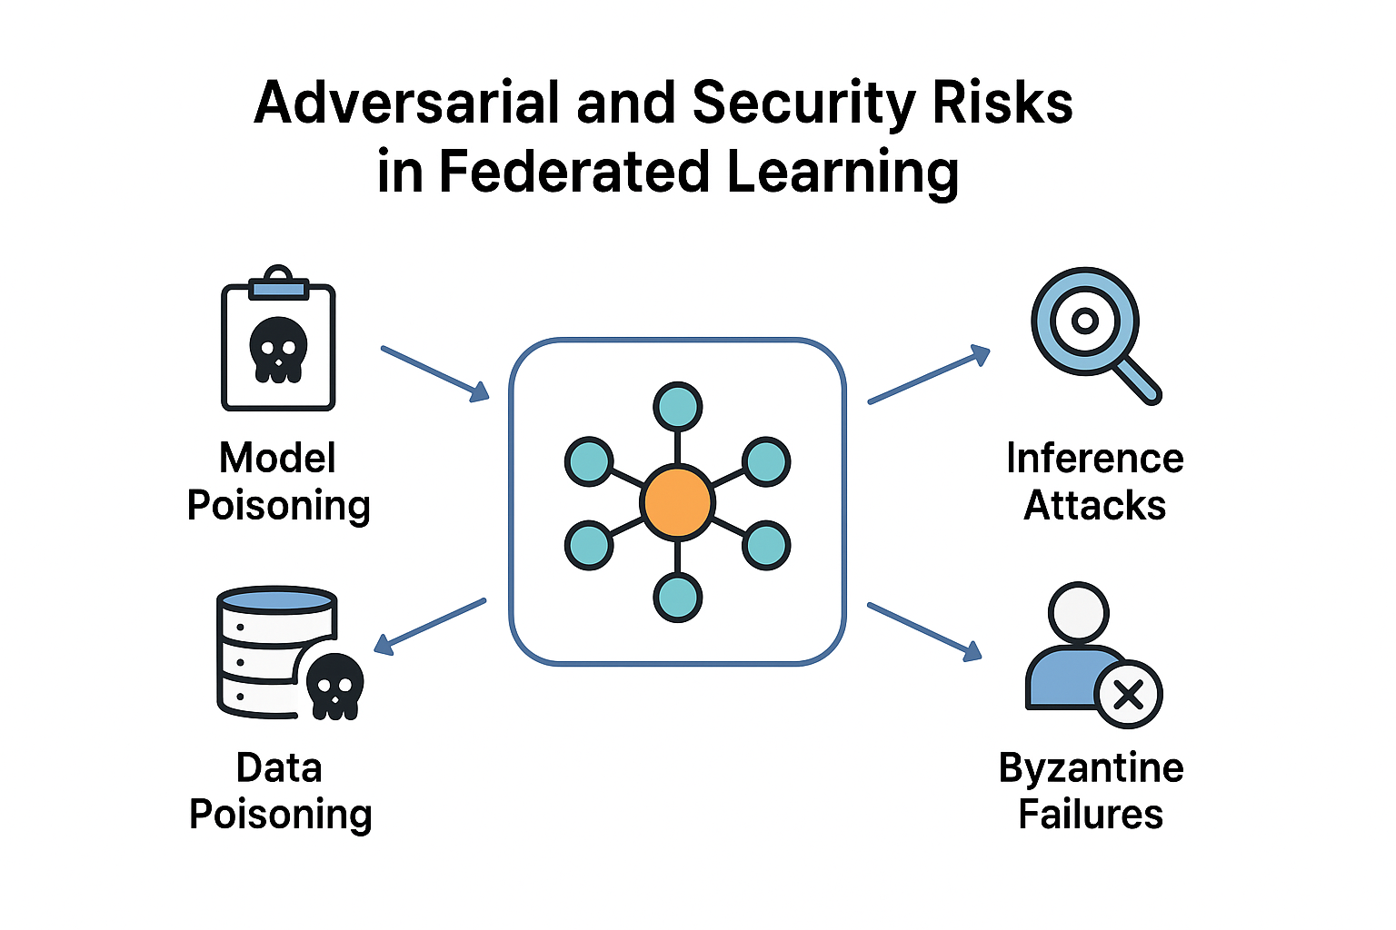
Figure 5.: Adversarial Risks and Security Risks in FL
The above fig represents how important is security issues in FL like model poisoning , data poisoning attacks etc Each risks shows that which risks arise in a decentralized collaborative learning.
7.3 Model Bias and Non-IID Data
Healthcare Data is considered to be Non-IID (non-independent, identically distributed data) which means data from different hospitals are not same. For example, many individuals receives treatment at small community hospitals in terms of age, types of diseases , other health problems etc. A study with eye images from Singapore, China and Taiwan found FL model successfully learned from non-IID data . Success on the model illustrates the tasks of myopic macular degeneration (MMD) detection which is used for assessing eye health[3].
8. Ethical, Legal and Social Considerations:
The merger of federated learning & agentic AI in healthcare will force serious considerations of ethical, legal and societal issues. These could profoundly revolutionize diagnostic development but the capabilities for autonomous action & use of personal data shows sophisticated dilemmas. The below section will explore the key considerations in these domains.
8.1 Algorithmic Bias
As we know , AI models could unintentionally learn and amplify biases contained in the training data. In FL the cause of models with performance disparities among various demographic groups or populations could be due to data heterogeneity. From a fairness Perspective , a diagnostic model could be sometimes less accurate for a particular population groups as the training data lacked the representation for that group[2].
8.2 Explainability and Transparency
AI systems which rely especially on deep learning are often known as “black boxes” as they are very complex and also lack of transparency about decision making processes. These principles & explanations for ML responsibility are the key factors for ensuring that the AI could be trusted by healthcare professionals and patients.
The explainability of AI will permit healthcare professionals to assess the reasons behind AI recommendations. Important in complex cases where human experience should be factored into both clinical and data evidence that will be produced by AI . Challenged by Federated agentic AI as the process of decision making is spread among various autonomous agents which are operating under different context.
8.3 Legal Compliance (HIPAA, GDPR and beyond)
Federated agentic AI frameworks are promoted commonly for their intersection with privacy regulations such as HIPAA in the US & GDPR in Europe as they do not centralize the personal data ( Rieke et al, 2020). For example , GDPR stresses the rights of the data subjects which includes explainability & the right to be forgotten that are almost impossible which fully implement in distributed AI processes[3].
GDPR | HIPAA
Right to data access | Right to access Records
Right to erasure | Right to request corrections
Right to be informed | Right to obtain copies
Right to restrict processing | Right to restrict disclosures
Right to data portability | Right to be notified of breaches

The above table gives the summary of patient rights which are under GDPR and HIPAA when applied to federated agentic AI systems manging health data.
9. Future Directions:
Development of FL and Agentic Artificial Intelligence is considered as a disruptive opportunity in health care. Unlocking the true potential of the technology requires us to address current push through the innovations which can meaningfully change federated agentic systems in such ways that could increase the adaptivity , equity & scale.
9.1 Adaptive Clinical Trial Optimization
Federated agentic AI has the ability to change how clinical trials are designed and run. Many agents participating from different institutions will be able to store the participant data individually , semi-autonomously even modify other trials, and could even collaborate on shared models concurrently without breaking the privacy and confidentiality[2]. These systems enables faster recruitment & sometimes early identification of adverse events by the process of medical innovation process.
9.2 Personalized and Precision Healthcare
Future of federated agentic AI expects an extremely important part for delivering of highly personalized care which would be by constantly improving models in relation to local patient populations & even allowing for privacy . This promotes additional precision in deciding diagnostic recommendations which would be applied to individual genetic , lifestyle & their environmental characteristics (Topol 2019) . It will make the recommendations which are based in the sensor data ( real-time) and then processed from wearables which contributes to greater level of personalization.
9.3 Real-Time Multi-Agent Health Monitoring Networks
Multiple networks of agents could utilize data that is available to them so that they could identify health population across a wide area. It will help with the fast & early identification of the effective allocations of resources which arises during crises & the implementation of wide scale epidemiological studies , ensuring data privacy[4]. The data architecture discussed will need support with respect to edge computing and 5G/6G connectivity.

10. Conclusion :
The chapter introduces comprehensive overview of Agentic AI & Federated learning in the field of healthcare . Illustrates that AI could enable tremendous advancements in medicine, but data privacy is a difficult issue with the proliferation of EHRs (Electronic Health Records). Gives the insights that how health data are typically of the highest sensitivity , and they are also widely regulated in the United States which are covered by policies such as HIPAA.

It describes two of the latest technologies that could be applied to solve the issue. First , it describes Federated Learning as a ML approach for developing the shared AI models using decentralized data but also by not transferring any local data . Second it defines Agentic AI as AI that supports autonomous action & decision making with very little or no human interventions. By leveraging the privacy -preserving processes in FL with their autonomous decision making functionality which is available with agentic AI , can make disruptive advancements in predictive analysis without compromising ethics & laws .
Agentic AI has the ability to monitor the continuous compliances with data protection regulations , automatic flag potential risks and streamlines workflows which appropriate to clinical trials & drugs discovery.

In conclusion, it introduces that the possibility of synthesizing these two technologies – Federated Learning & Agentic Artificial Intelligence as a means of creating & securing the concerns which are primarily associated with the serious issues of data privacy which includes leakage of sensitive data & even the potential for re-identification. It describes the future & a vision of healthcare innovation which is free from privacy , but also leveraging technologies which respect and protect human dignity[1][4][6].

References:
- Bajwa, J., Munir, U., Nori, A., & Williams, B. (2021). Artificial intelligence in healthcare: Transforming the practice of medicine. Future Healthcare Journal, 8(2), e188–e194.
https://doi.org/10.7861/fhj.2021-0095

- Pham, T. (2025). Ethical and legal considerations in healthcare AI: Innovation and policy for safe and fair use. Royal Society Open Science, 12(5), Article 241873.
https://doi.org/10.1098/rsos.241873

- Simbo AI. (2025, August). Addressing non-IID data issues in federated learning: Strategies for improving model performance across diverse healthcare settings. Simbo AI Blog. https://www.simbo.ai/blog/addressing-non-iid-data-issues-in-federated-learning-strategies-for-improving-model-performance-across-diverse-healthcare-settings-2694959/

- Xu, J., Glicksberg, B. S., Su, C., Walker, P., Bian, J., & Wang, F. (2021). Federated learning for healthcare informatics. Journal of Healthcare Informatics Research, 5(1), 1–19. https://doi.org/10.1007/s41666-020-00082-4

- Krylov, A. (2025). The value of data privacy in healthcare. Kodjin. Retrieved from https://kodjin.com/blog/the-value-of-data-privacy-in-healthcare/

- Kaissis, G., Ziller, A., Passerat-Palmbach, J., Ryffel, T., Usynin, D., Trask, A., Lima, I., Mancuso, J., Jungmann, F., Steinborn, M. M., Saleh, A., Makowski, M., Rueckert, D., & Braren, R. (2021). End-to-end privacy preserving deep learning on multi-institutional medical imaging. Nature Machine Intelligence, 3(6), 473–484. https://doi.org/10.1038/s42256-021-00337-8

- Park, J., & Lim, H. (2022). Privacy-Preserving Federated Learning Using Homomorphic Encryption. Applied Sciences, 12(2), Article 734. https://doi.org/10.3390/app12020734

- Wang, Z., Cai, L., Zhang, X., Choi, C., & Su, X. (2022). A COVID-19 auxiliary diagnosis based on federated learning and blockchain. Computational and Mathematical Methods in Medicine, 2022, Article ID 7078764. https://doi.org/10.1155/2022/7078764

- Sheller, M. J., Reina, G. A., Edwards, B., Martin, J., & Bakas, S. (2020). Multi-institutional deep learning modeling without sharing patient data: A feasibility study on brain tumor segmentation. Brainlesion: Glioma, Multiple Sclerosis, Stroke and Traumatic Brain Injuries, 132-143. https://doi.org/10.1007/978-3-030-46643-5_13

- Author(s). (2022). A privacy preserving framework for federated learning in smart healthcare systems . Computer Communications, Elsevier. https://www.sciencedirect.com/science/article/pii/S0306457322002680

